Java SE 8 New Features?

Advantages of Java SE 8 New Features?

What changes done to interfaces in java8.

Why static method added to interfaces?

Why default methods added to interfaces?

What is Lambda Expression?

What are the three parts of a Lambda Expression? What is the type of Lambda Expression?

What is a Functional Interface? What is SAM Interface?

Is is possible to define our own Functional Interface? What is @FunctionalInterface? What are the rules to define a Functional Interface?

Is @FunctionalInterface annotation mandatory to define a Functional Interface? What is the use of @FunctionalInterface annotation? Why do we need Functional Interfaces in Java?

When do we go for Java 8 Stream API? Why do we need to use Java 8 Stream API in our projects?

Explain Differences between Collection API and Stream API?

What is Spliterator in Java SE 8?Differences between Iterator and Spliterator in Java SE 8?

What is Optional in Java 8? What is the use of Optional?Advantages of Java 8 Optional?

What is Type Inference? Is Type Inference available in older versions like Java 7 and Before 7 or it is available only in Java SE 8?

What is Stream API in Java?

What is stream in Stream API?  
  
Explain stream operations with an example?  
  
How many types of Stream operations are there?  
  
  
What is Parallel Stream in Java Stream API?  
  
What is the benefit of using parallel stream?  
  
When parallel stream is used the Java runtime partitions the stream into multiple sub-streams.  
Can you use streams with primitives?  
  
How can you transform Stream to primitive type Stream?  
  
What are Reduction Operations in Java Stream API?  
  
Read more about Reduction Operations in Java Stream API here.  
What are Map operation in Java Stream API?  
  
What is a mutable reduction operation?  
  
What is a collect method in Java stream?  
  
What is FlatMap in Java?  
  
What is Spliterator in Java??

What is java.util.function.Supplier

Difference between Predicate, Supplier and Consumer ?

What are Method References?

Lab Work:

Lambda Expression

Write a lambda expression which accepts x and y numbers and return xy.

Write a method that uses lambda expression to format a given string, where a space is

inserted between each character of string. For ex., if input is “CG”, then expected output is “C G”.

Write a method that uses lambda expression to accept username and password and return

true or false. (Hint: Use any custom values for username and password for authentication)

\Write a class with main method to demonstrate instance creation using method reference.

(Hint: Create any simple class with attributes and getters and setters)

Write a method to calculate factorial of a number. Test this method using method reference

Feature.

Stream API

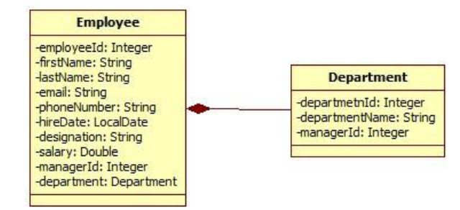

Create an EmployeeService class which queries on collections provided by EmployeeRepository class for following requirements. Create separate method for each requirement. (Note: Each requirement stated below must be attempted by using lambda expressions/stream API. It’s mandatory to solve at least 5 questions from following set. However, it is recommended to solve all questions to understand stream API thoroughly).

Find out the sum of salary of all employees.

List out department names and count of employees in each department.

Find out the senior most employee of an organization.

List employee name and duration of their service in months and days.

Find out employees without department.

Find out department without employees.

Find departments with highest count of employees.

List employee name, hire date and day of week on which employee has started.

list employee name, hire date and day of week for employee started on Friday. (Hint: Accept the day name for e.g. FRIDAY and list all employees joined on Friday)

List employee’s names and name of manager to whom he/she reports. Create a report in format “employee name reports to manager name”.

List employee name, salary and salary increased by 15%.

Find employees who didn’t report to anyone (Hint: Employees without manager)

Create a method to accept first name and last name of manager to print name of all his/her subordinates.

Sort employees by their

Employee id

Department id

First name